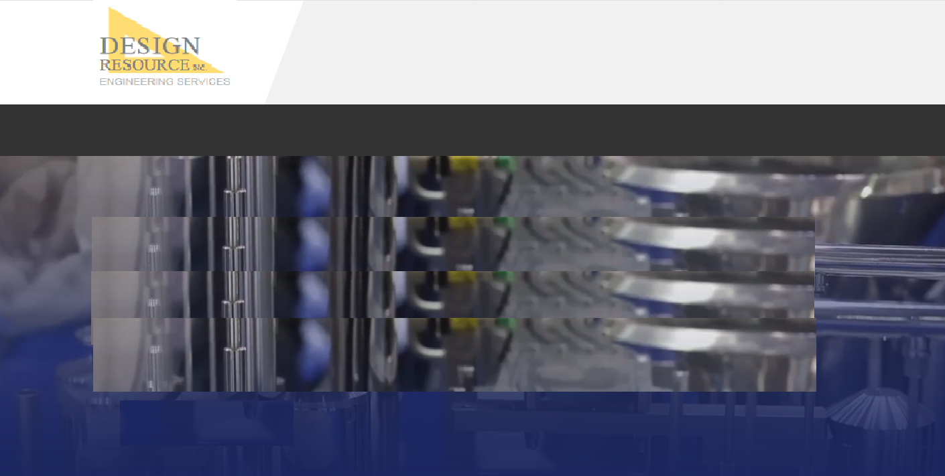

**Traditional Staffing**

* Candidates for all of your staffing requirements
* Contract terms tailored to suite your project needs including short term, long term, or contract to direct hire.
* Direct hire sourcing

***A wide range of traditional staffing options available to meet your needs.***

**HOME | ENGINEERING | STAFFING | COMPANY | CONTACT**

**© 2019 DESIGN RESOURCE, INC.**

**Traditional Staffing**

**HOME ENGINEERING STAFFING COMPANY CONTACT**